**Changes still to be made – to be read in conjunction with work checklist.**

**Add an I am over 18 check box when registering.**

**Login / Join up page changes (done this point)**

The “not a member yet” – “Join Now” is not very obvious and will lead to confusion for people.

Please can you put two buttons where the blue “sign in” button is. One button for “Sign in” one button for “not a member yet Join now” This needs to be very clear other wise it will frustrate people.

Keep the “forgot password” link there and the “remember password” they are good.

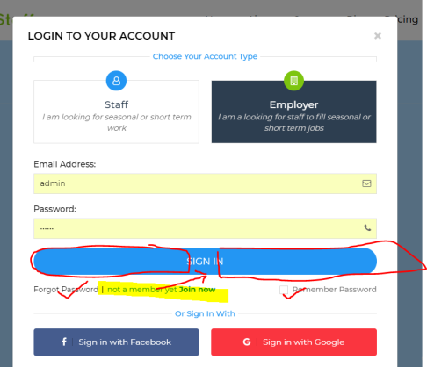

**Join up page –phone number (done this point)**

New Zealand phone numbers are 9 numbers long, cellphones can be 10-12 numbers long.

Please can you allow a window of 9-14 numbers in this field (to allow for international codes also)

Please can the error message be please “please enter a valid phone number”

**Adding in pricing selection buttons to registration page.**

Also below the password boxes – if the person registering is an employer then they will have 4 pricing options to choose from here. (this could be a radio button to select)

Needing 1-50 staff $199 +GST (see further info) –(See further info would be a link to pricing page detailing what they get for the pricing.)

Needing 51-150 staff $499 + GST (see further info)

Needing 151 – 500 Staff $799 + GST (see further info)

Needing 0ver 500 staff $999 + GST (see further info)

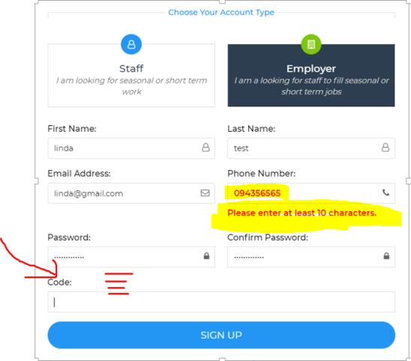

**Registration complete – page changes**

Once people have registered it show “Success Registration completed Successfully” but then they have to then login to get access, but there are no instructions telling them that they have to do that.

Please can you change the wording in the Green to “Success – you are now registered, Please log in to continue” – can the words also be in bigger and bolder font.

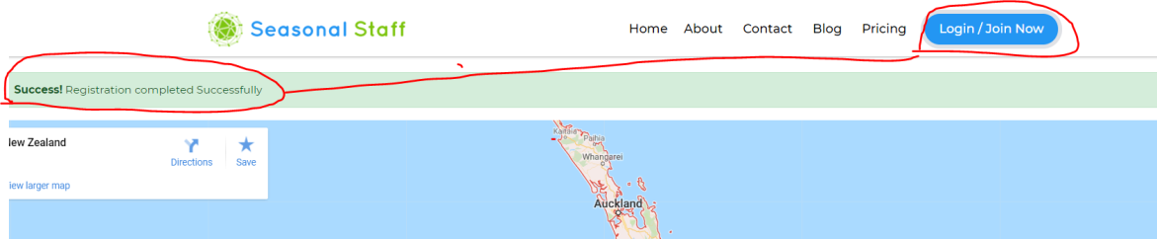

**Business info page.- action message**

When a business first logs on they come to their “business info” page.

There needs to be an “action message” that flashes up to get them to fill in all their details. Something like the below saying “Welcome please complete your business profile” It is not obvious what they have to do.

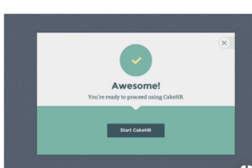

**Instruction messages on business info – profile page**

All the messages in “red” need to be instructions so they can see what they need to do. At the moment they only show once you have pressed “save changes” Can the messages be above the field that they need to fill in also.

**Phone number formatting dropping the first “0”**

The phone number that comes through from the registration page shows up missing the first number. This is usually a “0” can this be corrected please.

**Asking for “current password required cannot be empty”**

One the “Business info” page, if you update anything it asks for your password to be updated before you can move on. This will become very frustrating. It is good that there is a change password function there that they can do but it should be be something that needs to be updates all the time.

Can we hide this function under a Change password button with a drop down perhaps.

**Add “Search for Staff” and “list a job” button on the “Business info page”**

It is not obvious when you are in the “business info page” how to get to “Search for staff” or to “list a job” which will be the main to functions employers will want to do. Please can these buttons be added below the logout.

**Page tabs in the dashboard-.** Please can this be highlighted more so users know which page they are on.

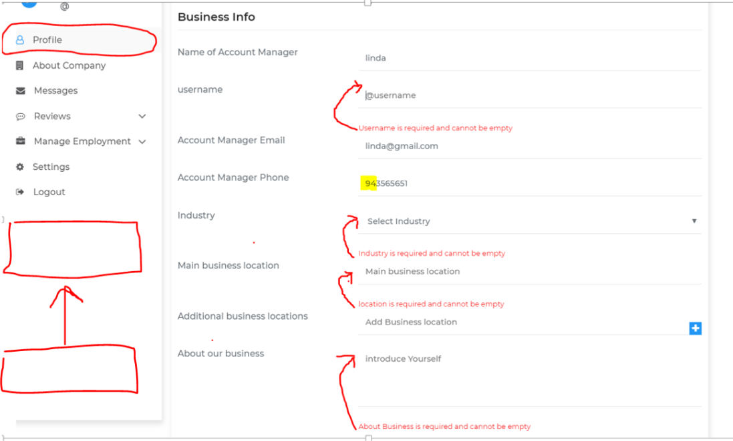

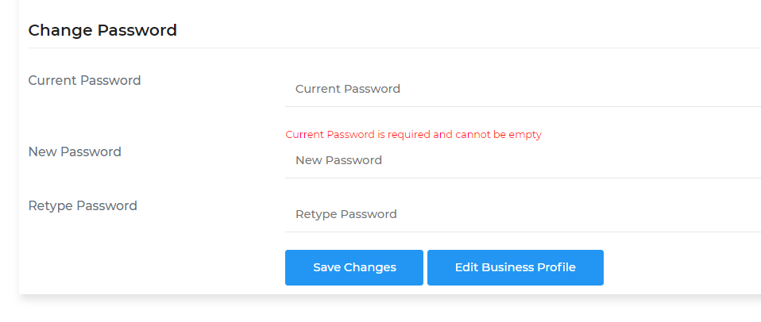

**Difficulty logging back into profile.**

The message that comes up when you are logging in as a business shows Staff. Can this be corrected please.

I know that we put the correct email and password in but it took three attempts to get it correct. Can this be looked into.. it does not flow well. You may need to add a “caps” sensitive message on.

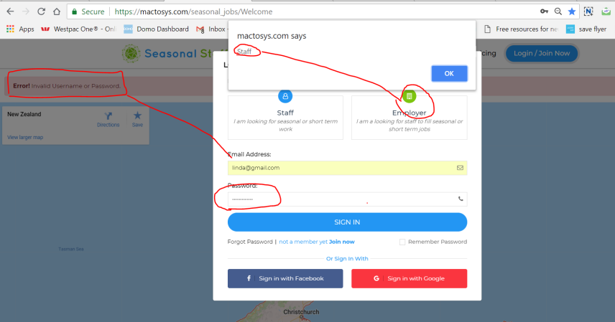

**Profile page – Industry selection**

When an employer selects their industry they are in – there is a drop down list. This is great however there is a selection of “all categories” this does not make sense in this area, but needs to be kept for other search fuctions – Please can this be removed from this drop down list.

**Business location- Google map location.**

In any of the business location fields that require an address, can the google address that come up be limited to New Zealand areas. Otherwise you end up searching through all sorts of countries.

**Additional business location.**

We have decided that this model of pricing will not work. Can the “additional business locations” be removed.

**Can “Main Business location”** be changed to “Business location”

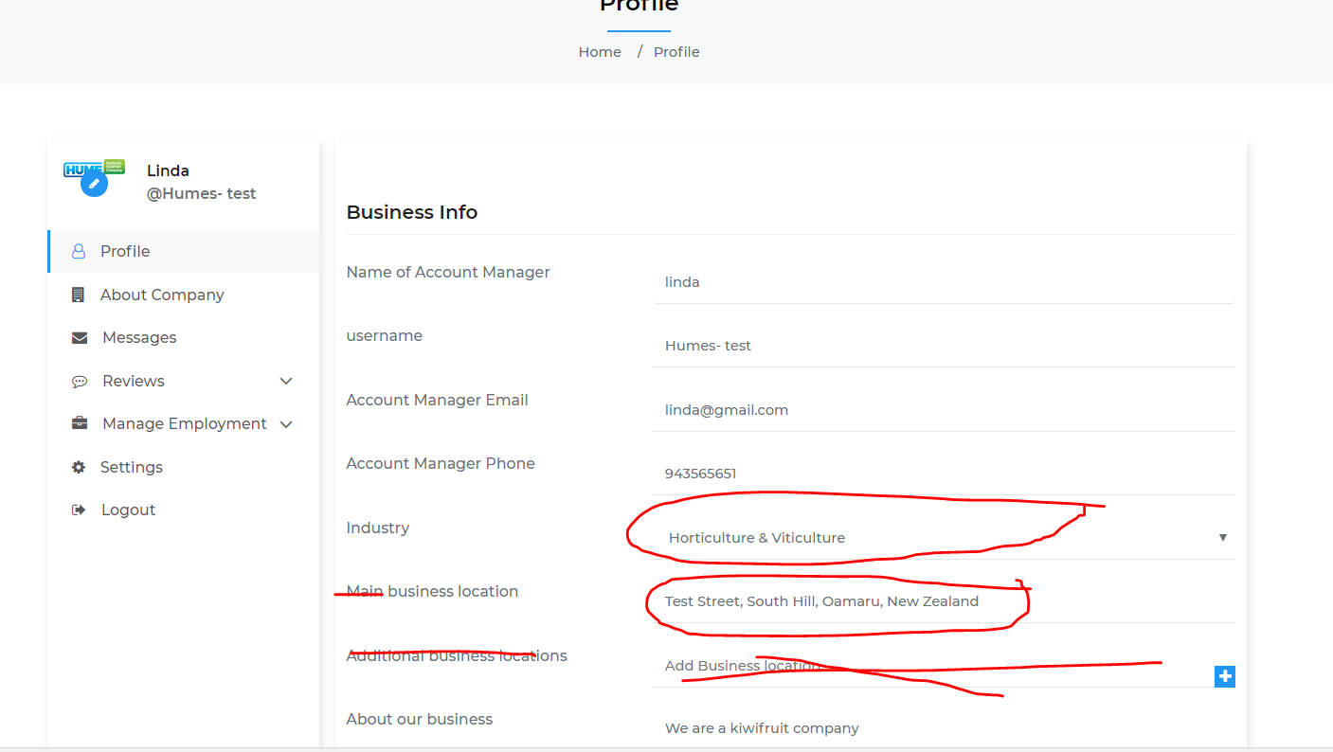

**Spelling mistakes. – on “list a Joab”**

Please can this be corrected to “list a Job”

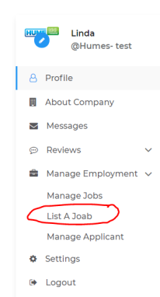

**List a Job – page fixes and changes**

Can you add instruction title“ How do you want to receive application” where the red line is.

**Either or function for “Receive CV” or “Receive Expressions of interest”**

We want this function to be an either or function. For example if they select “Receive full CV and cover letter” then it deselects “Receive expressions of interest” and visa versa. Only one can be selected at a time not both.

**Add in Contract type –**

Please can you add in under the Receive CV a section to select “type of contract” on with a drop down list showing “Fixed term” “Casual” “minimum hours” “other”

**Days of job calculator**

When two dates are selected by the below calendars, the incorrect number of days is calculated on the job advert. Please can this be corrected.

**Aprox Hours per week.**

Please can an additional field be added “By Negotiation” it would show as

By Negotiation

0-20 hours per week

20-40 hours per week

40 + hours per week

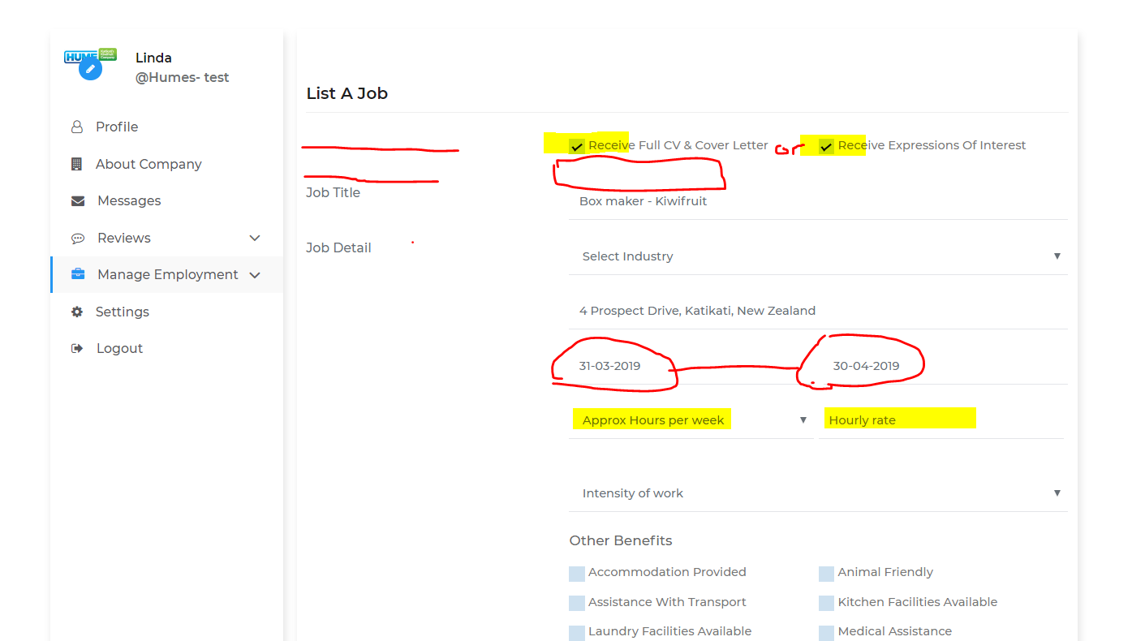

**Add Compulsory field Astrix (*)**

On all input fields throughout the website, can we show an astrix (*) to show what are the compulsory fields that need to be entered. This will save a lot of time and frustration for people who are entering information.

**Display Skills and Attributes like “other benefits”**

Please can Skills and attributes be displayed (checkbox) like the other benefits. This makes it quick to find the key skills and attributes.

**Make Select package an optional field.**

This should not be a compulsory field (this is optional)

**Acceptance of T&C and Privacy Policy – Change of location**

This needs to be a box that is checked when people are registering. (this should be moved to the register page/ sign up page. With links to the “Terms and conditions” and “Privacy policy”

**Change of wording for Check box**

I would like to keep that a customer has to check a box every time they list a job “ that they will abide by all NZ employment & human Rights legislation. ( keep the acceptance button here- we will just change the working.

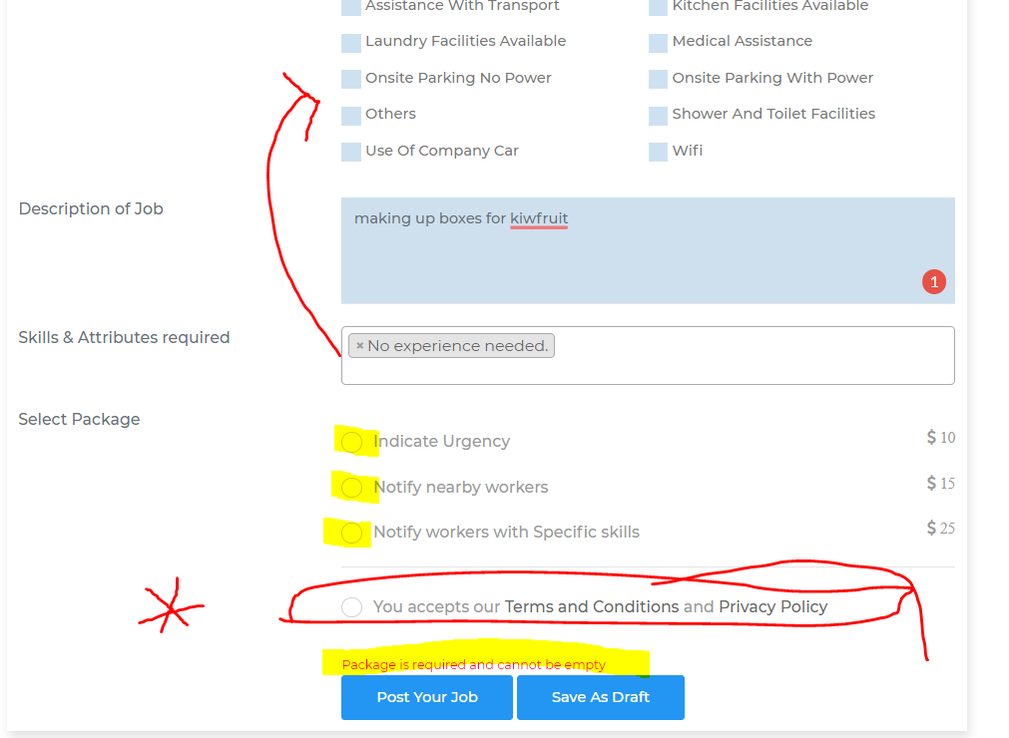

**When a job is loaded and you are looking at the preview.**

All the features have not come through correctly

Tabulation and display of address looks incorrect

Hourly rate is not displayed

Only 1 of the benfits are showing up.

No details for Contract type.

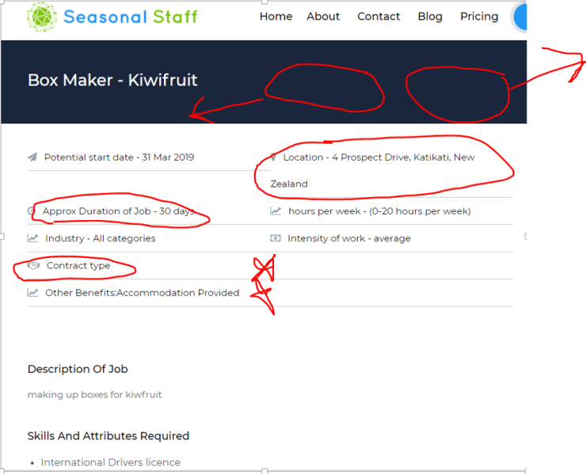

**Can you add a return to “Edit job listing” or “publish” button**

When you have created a job advert and you preview it…. When you are in the preview page, there is no direction to take you back to “edit the job listing” or “publish” please can these be added as it does not flow correctly with our these.